Impact of Ammonium Sulfate to heart beat of Daphnia magna
Name:
Course name/code:
School Affiliation:
Mentor:
Date:

To study the effect of Ammonium Sulfate to heart beat of Daphnia magna
Introduction
In this research study, the principle objective is to discover the impact of ammonium sulfate to the heart beat of Daphnia magna. Daphnia magna is a translucent amphibian living organism whose inside organs e.g. the heart can be seen with the help of a magnifying lens. Ammonium sulfate, whose chemical formula is [(NH4 )2SO4] is generally utilized nitrogen-based compost in agribusiness. A number of research has been done to explore the dangerous impacts of ammonium sulfate to aquatic life. The study is intended to explore the impacts of different concentrations of ammonium sulfate fixations on the heartbeat of Daphnia magna through an altered intense poisonous quality testing (American Fisheries Society, 2010). Centralizations of ammonium sulfate used in the study are as follows; 0.05M, 0.16M, 0.20M, and 0.30M. The test was done through observing the impacts of various ammonium sulfate concentrates on the Daphnia magna heart rate (Organistion for Economic co-operation and develoment (OECD)., 2014).
The rise of heart rate of Daphnia magna after being subjected to the different concentrations of ammonium sulfate at different concentrations were figured and an analysis done of the differing ammonium sulfate concentrates and the heart rate of Daphnia magna was plotted using information acquired in the test. Results demonstrated that the rise of ammonium sulfate concentrate at different intervals resulted to the rise in heart rate of Daphnia magna every moment, up to the 0.20M level. Rising concentrates of ammonium sulfate concentrates over 0.20M concentrate brought about a reduction in the heart rate of Daphnia magna for the subsequent addition of the concentration (American Fisheries Society, 2010).
Generally, ammonium sulfate is dangerous to the ecosystem and Daphnia magna is an aquatic organism that has been affected as well other sea-life. If the concentration of ammonium sulfate is not controlled, it results to the increase of oxygen requests in water bodies, which leads to high demand of oxygen in the water, henceforth, aquatic life die (Seco, Fernandez-pereira, & Vale, 2013). Together, these affect the environmental balance, as well as the health of the ecosystem and the oceanic biological system. Agribusiness might have high concentrates of nitrates and phosphates which are commonly used to supplement soil to increase yield. However, these concentrates find themselves in the river, down to the sea. This scientific study along these lines planned to explore the impacts of ammonium sulfate concentrate on the heartbeat of Daphnia magna. Daphnia magna is one of the freshwater shellfish, which is commonly used as a part of eco-harmfulness tests. This makes Daphnia magna a perfect test in the examination of heartbeat subjected to different ammonium sulfate concentrates (Ross, Ross, & Ross, 2011).
Materials and Methods
The students were organized into groups of five. Each groups was provided with various materials such as the timer, Kimwipes, microscope, depression slides, disposable pipettes, and a counter. First, the experiment was done with the use of water followed by ammonium sulfate treatment. The students first set up the microscope, and all the materials needed and proceeded to get Daphnia magna onto the depression slide. A living Daphnia magna from the culture was obtained and put on the depression slide. Water was carefully drawn out of using a Kimwipe. In this examination, the Daphnia magna culture media utilized for all investigations was made by dissolving the salts as follows 2.59 g of NaHCO3, 0.25 g of KCl, 4.93 g of MgSO4.7H2O, and 11.76 g of CaCl2.2H2O, in 1 L of Millipore ultrapure water to make stock arrangements. 25 mL of each salt concentrate was made to 1 L volume using the Millipore ultrapure water in order to get the right culture media. This was formed up by dissolving ammonium sulfate salt, 13.21g or Sigma A-4418, ≥99.0% in a volume of about 100cm3 of culture media in order to form solution of 1M. Different groupings of test concentrates of the solution 0.05M, 0.16M, 0.20M, and 0.30M were put in test tubes and perfectly marked. 0M culture media was used as a control solution as an affirmation that in case of adjustment Daphnia magna heartbeat was as a result of subjection to ammonium sulfate concentrates as grouped. Daphnia magna examples were expelled from the tubes independently utilizing a plastic dropper and set on the depression slide. It was then left immaculate for 2 minutes all together for the heartbeats of Daphnia magna to balance out back to ordinary in order to diminish automatic fluctuations in the heart rate which could cause disturbance while exchanging the examples. The student will observe the heartbeat of the Daphnia magna at intervals while the others put on the time, recording the results in a table etc.
For every minute, the solution was then expelled from the depression slide using tissue to decrease versatility of Daphnia magna. 50 μll of 0.05M ammonium sulfate arrangement was then exchanged using a micropipette from the test tube to the cavity slide to open the sample to the ammonium sulfate arrangement. The sample was left in the test answer for around 2 minutes. Excess solutions of the test was expelled from the cavity slide utilizing tissue paper and the pulse of the example was watched utilizing a light magnifying instrument under 4X amplification. Information was gathered by observing and recording 1minute video clasps of the heartbeats of the example by joining an advanced camera to the eyepiece of the microscope. The method was then rehashed for the rest of the centralizations of ammonium sulfate arrangement. At least 10 Daphnia magna samples were presented to every grouping of ammonium sulfate arrangement. The mean rate change in heart rate was ascertained in order to get a set of patterns of the various focuses.
Results:
Different samples of Daphnia magna were put on the depression slide and the heart rate was determined by observing the heartbeat of the various samples under the magnifying lens. In the initial water test containing the Daphnia magna sample was blotched dry which was followed by presenting Daphnia magna to separate centralizations of ammonium sulfate concentrates for around 1 minutes just before the heartbeat was thereafter estimated.
The following is the experimental treatment on D. magna
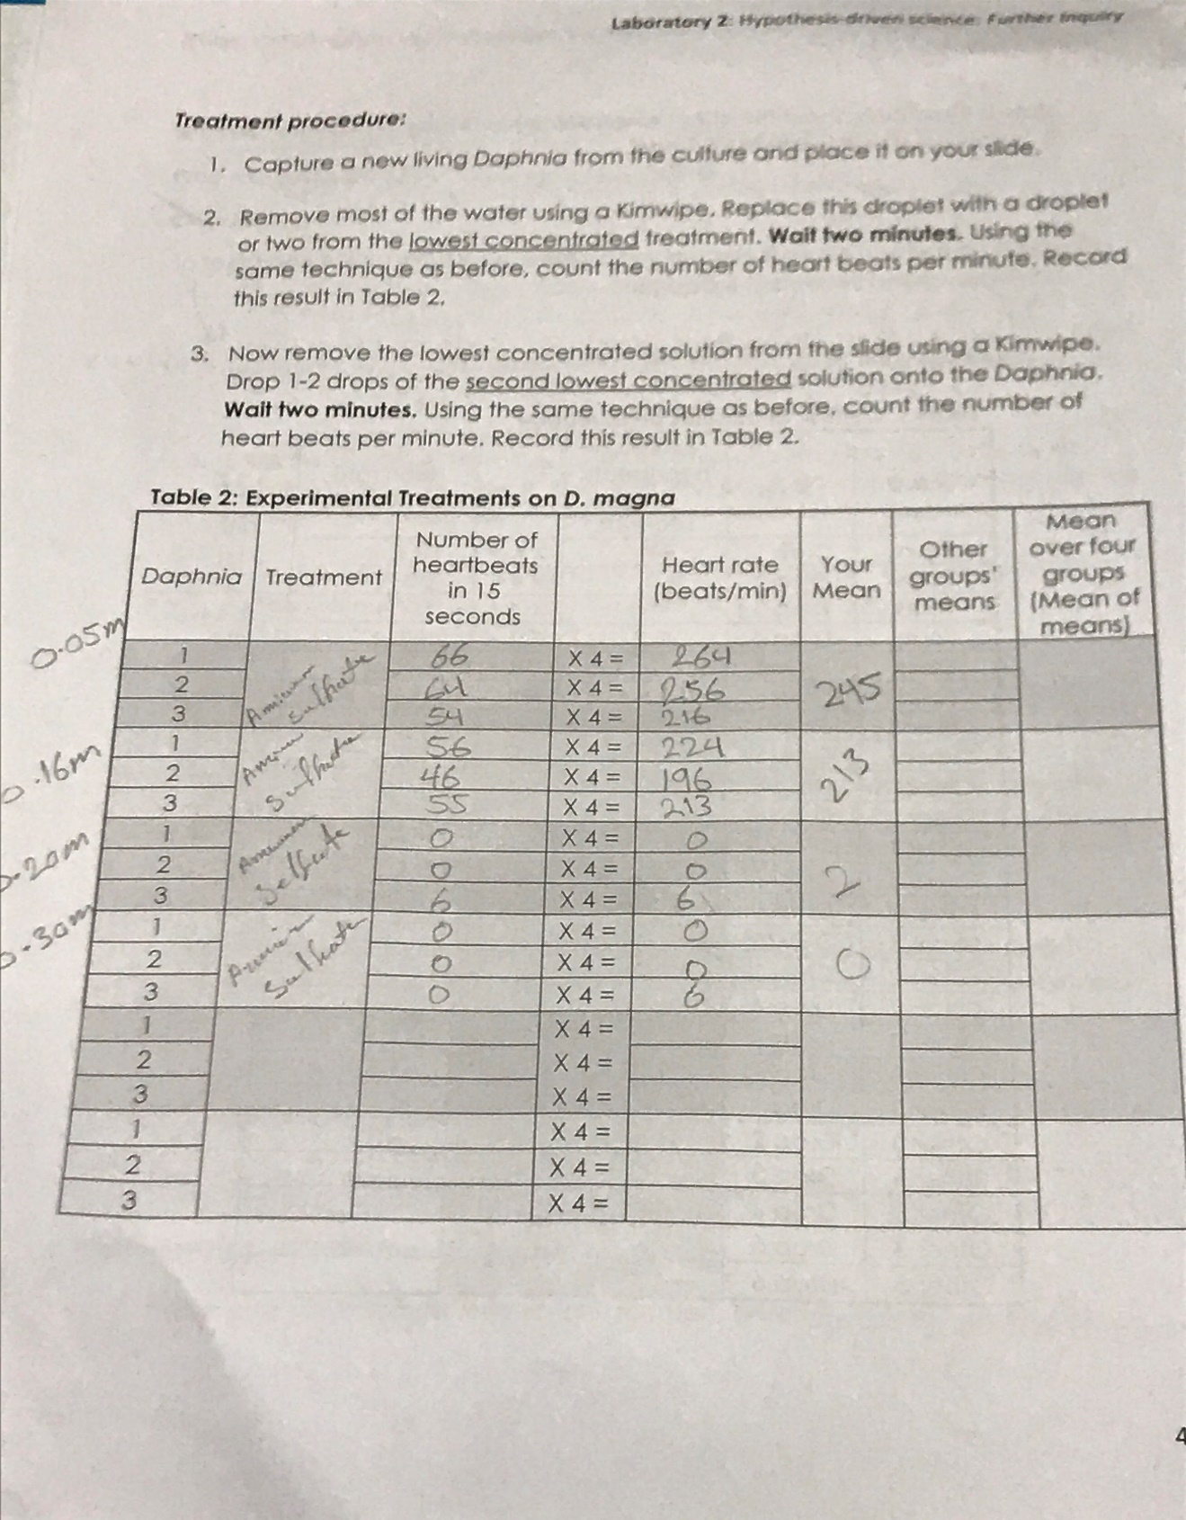
Table A- The Heart rate of Daphnia magna in culture media
 |  |  |  |  | Specimen number
 | 1 | 2 | 3 | 4 |  | 5 | 6
Number
of heart | 176 | 204 | 196 | 220 |  | 220 | 220
beats

Table B- The Heart rate of Daphnia magna in 0.05moldm⁻³ ammonium sulfate solution for1minute

 |  |  |  | Specimen
 |  | 1 | 2 | 3
 | Before
Number | addition | 66 | 64 | 54
Number | of test
of heart | solution
beats in | With
1 min | 0.05 | 264 | 256 | 216
 | moldm⁻³
 | test
 | solution
Table C- The Heart rate of Daphnia magna in 0.16 moldm⁻³ ammonium sulfate solution in 1 minute

 |  |  | Specimen
 |  |  | 1 | 2 | 3
 |  | Before
 | Number | addition | 56 | 46 | 55
 | Number | of test
 | of heart | solution
 | beats in | With
 | 1 min | 0.16 | 289 | 281 | 245
 |  | moldm⁻³
 |  | test
 |  | solution
Table D- The Heart rate of Daphnia magna in 0.2 moldm⁻³ ammonium sulfate solution in 1minute

 |  |  | Specimen
 |  | 1 | 2 | 3
 | Before
Number | addition | 0 | 0 | 6
Number | of test
of heart | solution
beats in | With
1 min | 0.20 | 0 | 0 | 6
 | moldm⁻³
 | test
 | solution

Table E- The Heart rate of Daphnia magna in 0.30 moldm⁻³ ammonium sulfate solution in 1 minute

 |  |  |  | Specimen
 |  |  | 1 | 2 | 3
 |  | Before
 |  | addition | 0 | 0 | 0
 |  | of test
 | Heart | solution
 | beats in | With
 | 1 min | 0.30 | 0 | 0 | 6
 |  | moldm⁻³
 |  | test
 |  | solution
Table F- The Overall percentage change in heart rate of Daphnia magna in the various

concentrations of test solution

 |  |  | (moldm⁻³)
 |  | 0.05 | 0.16 | 0.20 | 0.30
 | Before
 | addition of | 176 | 204 | 196 | 220
 | test
Daphnia | solution
heart | After
rate | addition of | 264 | 256 | 216 | 224
(beats | test
per | solution
minute) | Percentage + 16.7 |  | + 54.8 | + 81.1 | + 54.8*
 | change(%)
 | (to 1 d.p.)

The following is a 95% confidence interval for the values
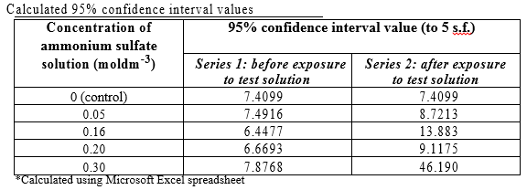
The heartbeat of the Daphnia magna pre and post exposure to the ammonium sulfate concentrations
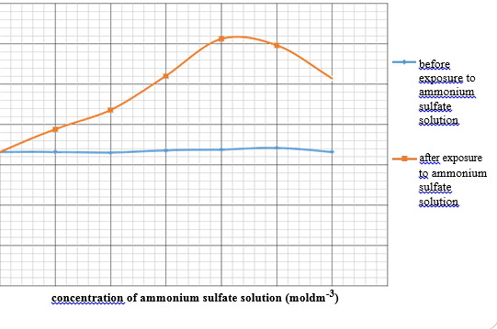
Discussion
From the experiment, the decrease in dosage of ammonium sulfate led to a decrease in heartbeat of Daphnia magna while an increase in treatment led to a decrease in heartbeat.
The study was meant to research the impacts of increased levels of ammonium sulfate on the sample, Daphnia magna, one constraint of this examination is that it was not able discover particularly the physiological component of Daphnia magna that was influenced by ammonium sulfate. In this trial, just changes in heart rate were researched. Ammonium sulfate could have additionally influenced different parts of Daphnia magna digestion, for example, circulatory framework or the respiratory framework. Ammonium sulfate is a feeble soluble base because of the nearness of smelling salts (NH3) in watery environment. At the point when ammonium sulfate compound separates, it produces alkali particles furthermore, the ammonium sulfate particles, which led to variances in pH of the concentrates, and henceforth, measure of un-ionized NH3 exhibit in the arrangement. Changes in pH may be a frustrating variable bringing about the passings of Daphnia magna examples.
Variances in concentrate’s pH may have changed the metabolic order of the sample, Daphnia magna. High pH may meddle with various metabolic procedures of the examples, for example, oxygen use in the body and vigorous digestion in various shellfish species. On account of Daphnia magna, take-up of oxygen is extremely discouraged at high pH esteems while at the same time it isn't impacted by low pH esteems. Higher concentrates of ammonium sulfate concentrates result to more un-ionized NH3 pattern in the concentrate, which leads to rise in alkalinity hence higher pH levels. Thus, a rise in concentration of ammonium sulfate, makes the heartbeat of Daphnia magna to rise in order to cover for the decrease in oxygenated blood pumped through the body keeping in mind the end goal to remunerate the decline in oxygen take-up at higher pH. Oxidative phosphorylation is a chemical ward process, there a rise in in alkaline content of the concentrate may have in this manner diminished the proficiency of respiratory compounds in doing their capacities in the ATP amalgamation. Variances in pH may disturb the bonds, thus modifying the compliance of the dynamic site of the protein. This lessens the capacity of the compound to work ideally by repressing its capacity to shape substrate-catalyst complex, henceforth diminishing rate of ATP creation in the body of Daphnia magna. Since ATP creation is extraordinarily debilitated, Daphnia magna needs to build its heartbeat in order to expand the take-up of oxygen for oxidative phosphorylation and in this manner the measure of ATP created. Promote intense lethality tests could be done to decide the LC50 and LD50 of ammonium sulfate concentrate on Daphnia magna.
Furthermore, the deadly convergence of ammonium sulfate that is required to kill a large portion of the number of inhabitants in Daphnia magna examples of a settled example size could be precisely decided. There is a plausibility that it probably won't be the lethality of ammonium sulfate that brought about the inevitable demise of Daphnia magna at higher focuses however it may be the individual impact of either alkali particle (NH3) or sulfate particles (SO42-) when ammonium sulfate separates in fluid arrangement. It was discovered that alkali danger is because of the un-ionized type of NH3 given that the most elevated harmfulness of ammonium sulfate is at pH 8. A comparative trial could be done by testing other salt arrangements containing either smelling salts or sulfate mixes. For instance, the comparative investigation can be done utilizing ammonium chloride, which will give the smelling salts particle, and magnesium sulfate, which will give the sulfate particle. An examination should then be possible to decide whether salts containing alkali or sulfate particles have a similar impact on Daphnia magna. This data would then be able to be utilized to decide whether the adjustment in heart rate of Daphnia magna examples were because of the smelling salts particles, the sulfate particles or both.
In the biological setting, ammonium sulfate would not be the sole contaminant in water
bodies. Its communications with different mixes, for example, overwhelming metals may have more unfavorable impacts on Daphnia magna when contrasted with ammonium sulfate itself. Subsequently, facilitate proposals to observing of the environment could be reached out by testing blends of mixes with ammonium sulfate on Daphnia magna.

References
American Fisheries Society. (2010). Transactions of the American Fisheries Society. Bethesda, MD, etc: American Fisheries Society.
Jose, C., Chatelain, E.H., & Dufresne, F. (2015). Low flexibility of metabolic 320 capacity in aubartic and temperate cytotypes of Daphnia pulex. Journal of Thermal 321 Biology 34, 70-75
National Agricultural Library (U.S.), & United States. (2012). Bibliography of agriculture. New York: CCM Information Corp.
Organistion for Economic co-operation and develoment (OECD). (2014). Ammonium 333 Sulfate. Germany: United Nations Environment Programme chemicals unit
Ross, L. G., Ross, B., & Ross, B. (2011). Anaesthetic and sedative techniques for aquatic animals. Oxford: Blackwell.
Seco, J. I., Fernandez-pereira, C., & Vale, J. (2013). A study of the leachate toxicity 335 of metal-containing solid wastes using Daphnia magna. Ecotoxicology and 336 Environmental Safety 56 , 339-350.
SETAC (Society). (2012). Environmental toxicology and chemistry. New York: Pergamon.

